**Daniel Williamson**

**Project #6**

**10/24/16**

**CS 212**

[**http://cefns.nau.edu/~daw277/index.html**](http://cefns.nau.edu/~daw277/index.html)

Project Overview

Purpose:

The purpose of this project was rather simple. Considering I had already completed for project #5 because it made it easier to make sure the information was being passed. So, the purpose was to create a verification email. As in, send an email to the user to let them know whether or not their information was passed on. We will also be sending an email to myself each time to user hits send. We do this by using a CC.

Approach:

The approach was once again, simple. I immediately ran to google and started doing some research. W3schools was once again, extremely helpful. Once I felt comfortable with what I needed to accomplish I got to work. I started with setting up a simple mail function. It didn’t say much, but I got it to send an email. Which was fantastic. After getting that up and running, I began working on making it look more polished. Added some fluff. I also made sure to add a date stamp. So that the user knows, and I, which day the email was sent. I always made sure that I myself got a CC of the varication email the user would receive.

Results

These are my results:

This is my mail function. Pretty basic.



These are my headers. The first one allows me to send an email to myself when a user hits send. The CC, creates a carbon copy.

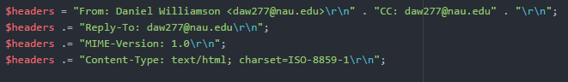

This is the body of the verification email. It’s what the structure looks like in the email itself. Used HTML to create it.

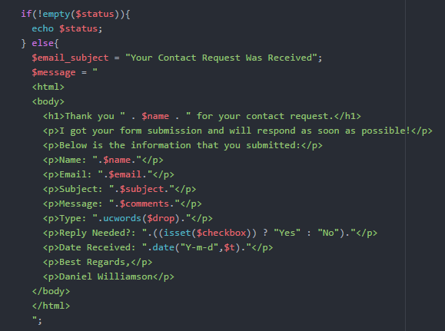

Testing:

This is the email sent to the user. Also a complaint was made by one of my buddies…

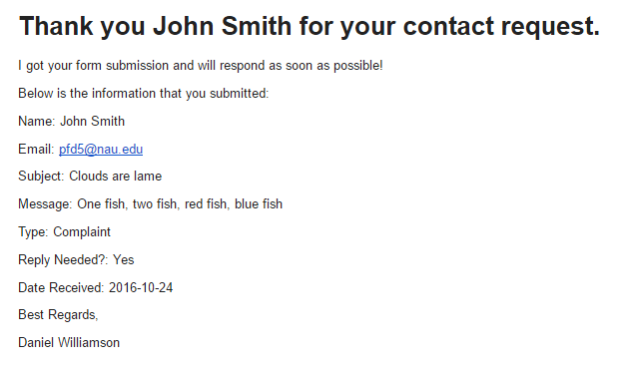

Conclusion

In conclusion, this was a fun lab. As usual I learn a lot about programming in HTML and PHP and I always look forward to doing more projects. The toughest part about this lab was knowing that I need specific headers to get it to work correctly. I feel like that was not well explained in class. I pier of mine pointed that out to me thankfully. Which made my life much easier.